Student Performance Prediction using ML

A PROJECT REPORT

Mini Project (01CE0609)

Submitted by

Mayank Ashishbhai Shukla
92410103121

Harsh Dineshbhai Vadgama
92410103123

BACHELOR OF TECHNOLOGY
in
Computer Engineering


Faculty of Engineering & Technology Marwadi University, Rajkot

April, 2026

Mini Project (01CE0609) Department of Computer Engineering Faculty of Engineering & Technology Marwadi University

A.Y. 2025-26

CERTIFICATE

This is to certify that the project report submitted along with the project entitled Student Performance Prediction has been carried out by Mayank Ashishbhai Shukla 92410103121 , Harsh Dineshbhai Vadgama 92410103123 under my guidance in partial fulfillment for the degree of Bachelor of Technology in Computer Engineering, 6th Semester of Marwadi University, Rajkot during the academic year 2025-26.

Dr. Dhara Joshi Prof. (Dr.) Krunal Vaghela

Assistant Professor Professor & Associate Dean Department of Computer Engineering Department of Computer Engineering



Mini Project (01CE0609) Department of Computer Engineering Faculty of Engineering & Technology Marwadi University

A.Y. 2025-26

DECLARATION

We hereby declare that the Mini Project (01CE0609) report submitted along with the Project entitled Student Performance Prediction submitted in partial fulfilment for the degree of Bachelor of Technology in Computer Engineering to Marwadi University, Rajkot, is a bonafide record of original project work carried out by me / us at Marwadi University under the supervision of Dr. Dhara Joshi and that no part of this report has been directly copied from any students’ reports or taken from any other source, without providing due reference.

Name of the Student Sign of Student

- Mayank Ashishbhai Shukla

- Harsh Dineshbhai Vadgama

Acknowledgement
We would like to take this opportunity to express our heartfelt gratitude to everyone who has supported and guided us throughout this project. Completing this mini project has been a truly enriching experience, and it would not have been possible without the encouragement and assistance of several individuals.
We are deeply grateful to our project guide, Dr. Dhara Joshi, Assistant Professor, Department of Computer Engineering, Marwadi University, Rajkot, for his/her constant guidance, valuable suggestions, and timely feedback throughout the development of this project. His/her support helped us navigate challenges and stay on the right path.
We also extend our sincere thanks to Prof. (Dr.) Krunal Vaghela, Professor & Associate Dean Department of Computer Engineering, for providing the necessary academic infrastructure and motivating us to put our best efforts into this work.
We are thankful to all the faculty members of the Department of Computer Engineering, Marwadi University, for their valuable inputs during the review sessions and for sharing their domain knowledge, which helped us improve the technical depth of our project.
A special mention goes to our friends and classmates who discussed ideas with us and helped us test our implementation. Their honest feedback was genuinely useful.
Finally, we are sincerely thankful to our families for their continuous support, patience, and encouragement throughout this journey. Their belief in us kept us motivated.

Mayank Ashishbhai Shukla Harsh Dineshbhai Vadgama
Department of Computer Engineering Marwadi University, Rajkot

ABSTRACT

Abstract

This project, Student Performance Analysis and Prediction, uses machine learning to analyze student data and predict GPA based on factors like study hours, attendance, parental support, and extracurricular activities.

The dataset (CSV) is processed in Python using Google Colab, with steps including data cleaning, handling missing values, encoding categorical data, and normalization. Exploratory Data Analysis (EDA) is performed to identify patterns and relationships.

Three models—Linear Regression, Decision Tree, and Random Forest—are applied and evaluated using metrics like MSE, MAE, RMSE, and R². The system can also predict GPA for new inputs and classify performance levels (Low, Medium, High).

The project is about 75% complete, with further work ongoing on pipeline integration and visualization.

List of Figures

Fig 1.1 Project Development Lifecycle (Agile/Iterative) 5

Fig 1.2 Gantt Chart for Project Schedule 6

Fig 3.1 System Architecture Diagram 12

Fig 3.2 Data Pipeline Flowchart 12

Fig 3.3 GPA Distribution Histogram 14

Fig 3.4 Correlation Heatmap of Dataset Features 15

Fig 3.5 Study Time vs GPA Scatter Plot 16

Fig 3.6 Absences vs GPA Scatter Plot 16

Fig 3.7 Parental Support vs GPA Box Plot 17

Fig 3.8 GradeClass Distribution Bar Chart 17

Fig 4.1 Actual vs Predicted GPA - Linear Regression 21

Fig 4.2 Model Comparison - R2 Score Bar Chart 22

List of Tables

Table 1.1 Technology Stack Summary 4
Table 1.2 Project Time and Effort Estimation 5
Table 1.3 Roles and Responsibilities 5
Table 2.1 Functional Requirements 8
Table 2.2 Non-Functional Requirements 8
Table 2.3 Algorithm Comparison and Justification 11
Table 3.1 Dataset Feature Description 13
Table 4.1 Model Performance Metrics Comparison 22
Table 4.2 Test Cases 23

ABBREVIATIONS

Abbreviation | Full Form
AI | Artificial Intelligence
CSV | Comma Separated Values
DT | Decision Tree
EDA | Exploratory Data Analysis
GPA | Grade Point Average
LR | Linear Regression
MAE | Mean Absolute Error
ML | Machine Learning
MSE | Mean Squared Error
RF | Random Forest
RMSE | Root Mean Squared Error
R2 | R-Squared Score (Coefficient of Determination)
SDLC | Software Development Life Cycle
Sklearn | Scikit-learn (Python ML Library)

Table of Contents

Acknowledgement Abstract
List of Figures List of Tables
List of Abbreviations Table of Contents

CHAPTER 1: INTRODUCTION AND PROJECT MANAGEMENT
  - Project Summary 1
  - Purpose 2
  - Objectives 2
  - Scope 3
  - Technology and Literature Review 3
  - Project Planning and Scheduling 4
    - Project Development Approach and Justification 4
    - Project Effort, Time and Cost Estimation 5
    - Roles and Responsibilities 5
    - Group Dependencies 6
  - Project Scheduling (Gantt Chart) 6
CHAPTER 2: SYSTEM ANALYSIS
  - Study of Current System 7
  - Problems and Weaknesses of Current System 7
  - Requirements of New System 8
  - System Feasibility 9
  - Activity / Process in Proposed System 10
  - Features of Proposed System 10

  - Main Modules of Proposed System 11
  - Selection of Algorithms and Justification 11
CHAPTER 3: SYSTEM DESIGN
  - System Design and Methodology 12
  - Data Structure and Process Design 13
  - Input / Output and Interface Design 14
CHAPTER 4: IMPLEMENTATION AND TESTING
  - Implementation Platform / Environment 19
  - Process and Module Specifications 19
  - Findings / Results / Outcomes 21
  - Result Analysis and Comparison 22
  - Testing Plan / Strategy 23
  - Test Results and Analysis 23
CHAPTER 5: CONCLUSION AND FUTURE ENHANCEMENTS
  - Overall Analysis of Project Viability 25
  - Problems Encountered and Possible Solutions 25
  - Summary of Project Work 26
  - Limitations 26
  - Future Enhancements 27
  - Project Outcomes and Discussion 27
Appendix 1: Dataset Feature Description 29
References 30

CHAPTER 1 INTRODUCTION

PROJECT SUMMARY
Now, more than ever, it is important to know the factors that influence the performance of students in the current academic environment. Schools produce vast quantities of information concerning student actions, attendance, study patterns and grades. Nonetheless, much of this information remains untapped as far as proactively establishing those students who have the potential of performing below par is concerned.
This project, Student Performance Analysis and Prediction, is a machine learning-based application created to examine different features of the student and predict the anticipated GPA of a student. The system takes in actual student data, finds the strongest contributing factors to academic performance, and constructs predictive regression models with Python in a Google Colab environment.
The essence is to provide educators and students with a data driven method of analyzing performance trends. Instead of using final exams alone or teacher intuition, this system adds a more analytical dimension of monitoring academic performance. The project is tackled with the help of CSV dataset of student records that has 15+ features, and three regression models are trained and compared with each other: Linear Regression, Decision Tree, and Random Forest, to find the most appropriate predictor.

PURPOSE
This project will serve the main purpose of filling the gap between raw academic data and meaningful insights. The current procedures of assessing student performance which largely rely on end term examinations or subjective measures fail to give timely intervention indicators.
The aim of this system is to:
- Provide students with an opportunity to comprehend what factors have the greatest influence on their GPA.
- Equip teachers with a prediction tool which can identify students requiring extra help.

- Explain the way machine learning can be used in practice in the sphere of education.
- Make data-driven decision making wherein multiple regression models are compared and the most effective one is chosen.

The project is not intended to substitute human judgment but to back it with quantitative analysis. It is also meant to be an educational machine learning, data preprocessing, and model evaluation exercise.

OBJECTIVES
The following objectives have been defined for this project:

- To collect and preprocess a real-world student performance dataset by removing duplicates, handling missing values, dropping irrelevant columns, and encoding categorical features.
- To perform Exploratory Data Analysis (EDA) to understand data distributions, correlations, and outliers using visualizations like histograms, scatter plots, heatmaps, and box plots.
- To implement and compare three machine learning regression models: Linear Regression, Decision Tree Regressor, and Random Forest Regressor.
- To compare between all the models with standard measures: MSE, MAE, RMSE, and R2 Score.
- To create a preprocessing and model pipeline based on sklearns Pipeline and ColumnTransformer to create an efficient data flow.
- To enable real-time GPA prediction for new student input.
- To categorize predicted GPA into Low, Medium, and High performance levels.

SCOPE
The scope of this project covers the complete machine learning pipeline starting from data loading to final GPA prediction. Specifically, the project handles:
- Loading and exploring a student performance dataset in CSV format.
- Preprocessing of data including cleaning, encoding, and scaling.
- EDA-based visual analysis of key features.
- Training and evaluation of multiple regression models.
- GPA prediction for new input data with category labeling.

The project does not cover:

- Any real-time integration with a college management or LMS system.
- A web-based or mobile front-end interface (currently planned as a future scope item).
- Classification-based models for predicting GradeClass (this is currently under development).
- Deployment of the model on a cloud server or as an API.

TECHNOLOGY AND LITERATURE REVIEW
To learn the state of the art in student performance prediction, as well as to choose the most suitable tools to use in this project, a survey of related work and technologies was carried out.

Related Work
The researchers have investigated the use of machine learning to forecast the academic performance of students in a number of studies. Cortez and Silva (2008) applied decision tree models to make predictions of student grades in Portuguese secondary schools with a reasonable accuracy. Ensemble methods such as the Random Forest and gradient boosting techniques have been used in more recent studies to obtain a higher accuracy. Deep learning techniques have been investigated as well but generally need significantly larger datasets. In our project, we have the regression-based models as the most appropriate, considering the size of the dataset and the intention to interpret the data.

Technology Stack

Table 1.1 below summarizes the complete technology stack used in this project.

Table 1.1 Technology Stack Summary

Category | Tool / Library | Purpose
Language | Python 3.x | Primary programming language
Platform | Google Colab | Cloud-based Jupyter environment
Data Handling | NumPy, Pandas | Numerical computation, data manipulation
Visualization | Matplotlib, Seaborn | Graphs, plots, heatmaps
Machine Learning | Scikit-learn (sklearn) | Model building and evaluation
Dataset | CSV File (Google Drive) | Student performance data

PROJECT PLANNING AND SCHEDULING

Project Development Approach and Justification
This project is based on the Agile/Iterative development model. The project was broken down into mini sprints with deliverables at each point rather than doing the entire project at a time. This method has been selected as it can gradually enhance it, depending on the intermediate testing and feedback.
The main phases of development are:

      - Phase 1: Problem Understanding and Dataset Selection
      - Phase 2: Data Preprocessing and EDA
      - Phase 3: Model Building and Training
      - Phase 4: Model Evaluation and Comparison
      - Phase 5: Prediction Module and GPA Categorization
      - Phase 6: Report Writing and Documentation

Fig 1.1 Project Development Lifecycle (Agile/Iterative)
Problem Understanding & Dataset Selection
↓
Data Loading → Data Cleaning → Feature Engineering
↓
EDA → Visualization → Correlation Analysis
↓
Train-Test Split → Preprocessing Pipeline → Model Training
↓
Model Evaluation → Comparison → Best Model Selection
↓
GPA Prediction for New Student → GPA Category Output

Project Effort, Time and Cost Estimation
Table 1.2 Project Time and Effort Estimation

Ph as e | Activity | Estimated Time | Status
1 | Problem Understanding & Dataset Selection | 1 week | Completed
2 | Data Preprocessing & EDA | 2 weeks | Completed
3 | Model Building & Training | 2 weeks | Completed
4 | Model Evaluation & Comparison | 1 week | Completed
5 | Prediction Module & GPA Categorization | 1 week | Completed
6 | Pipeline Integration & Advanced Viz | 1 week | In Progress
7 | Report Writing & Documentation | 1 week | In Progress

Roles and Responsibilities
Table 1.3 Roles and Responsibilities

Student Name | Primary Responsibilities
Harsh Vadgama | Data preprocessing, EDA, Linear Regression implementation, Report writing
Mayank Shukla | Decision Tree & Random Forest models, Pipeline building, Prediction module

Group Dependencies
This project was collaboratively worked by both team members who had to coordinate regularly with each other using shared Google Colab notebooks and informal meetings. Student 1 designed preprocessing that was used directly as input in the training of the model by Student
2. Likewise, prediction and scaler objects constructed in preprocessing were both needed by the prediction object and thus the two are dependent on each other.

PROJECT SCHEDULING (GANTT CHART)
Fig 1.2 Gantt Chart for Project Schedule

Phase / Activity | Jan | Feb | Mar | Apr
Problem Understanding & Dataset Selection | █████
Data Loading & EDA | █████ | ████
Data Preprocessing & Feature Engineering |  | █████ | ██
Model Building (LR, DT, RF) |  | ████ | ████
Model Evaluation & Comparison |  |  | ████
GPA Prediction Module |  |  | ████
Pipeline Integration |  |  | ███ | ██
Report Writing & Documentation |  |  | ████ | ████

CHAPTER 2 SYSTEM ANALYSIS

STUDY OF CURRENT SYSTEM
In most educational institutions today, student performance evaluation is done through periodic test results, attendance, and some comments by the teacher. The information gathered in the course of. student information systems store or in simple spreadsheet files, the academic year. While this data exists in abundance, its use is mostly limited to generating grade reports at the end of the semester.

Most colleges have no automated system to analyze the trends across several.
performance indicators. As an example, the correlation between the number of hours that a student studies per week, Pattern of attendance, and GPA are seldom studied in real time. Teachers have to rely on personal observations which are subjective and time-consuming.

Other universities have already started to consider analytics platforms, yet they tend to be costly, need IT teams, and cannot be available to smaller institutions. In the absence of such performance review meetings, tools are usually reactive, i.e. interventions are done after the occurrence of a. student has already failed, rather than beforehand.

PROBLEMS AND WEAKNESSES OF CURRENT SYSTEM
The following key problems exist in the current system of student performance monitoring:

- Absence of Predictive Analysis: The existing system merely documents the previous performance.there is no formula of forecasting the future GPA of a student, depending on his/her current behavior and study. habits.
- No Feature Correlation Study: There is no tool that examines what factors - such as Most strongly correlated with are study time, absences or parental support. academic outcomes.
- Manual Effort: Teachers have to manually review individual student records to identify at-risk students. This is time-consuming and prone to error

- Delayed Interventions: Because there is no early warning system, interventions often come too late for struggling students.
- No Personalized Feedback: The current system cannot generate individualized predictions or recommendations for each student.
- Data Underutilization: Large volumes of academic data are collected every semester but never analyzed beyond surface-level grade reports.

REQUIREMENTS OF NEW SYSTEM
Based on the problems identified above, the following functional and non-functional requirements have been defined for the proposed system.

Functional Requirements
Table 2.1 Functional Requirements

Req. ID | Requirement Description
FR-01 | The system shall load and read a CSV dataset containing student records.
FR-02 | The system shall preprocess data by handling missing values, removing duplicates, and encoding categorical variables.
FR-03 | The system shall perform EDA using histograms, scatter plots, box plots, and heatmaps.
FR-04 | The system shall train a Linear Regression model for GPA prediction.
FR-05 | The system shall train a Decision Tree Regressor model.
FR-06 | The system shall train a Random Forest Regressor model.
FR-07 | The system shall evaluate models using MSE, MAE, RMSE, and R2 Score.
FR-08 | The system shall accept new student input and predict GPA in real time.
FR-09 | The system shall classify predicted GPA into Low (<2.0), Medium (2.0-3.0), and High (>3.0) categories.

Non-Functional Requirements
Table 2.2 Non-Functional Requirements

Category | Requirement
Performance | Models must complete training within a reasonable time on Google Colab's free tier (< 5 minutes).

Category | Requirement
Usability | The notebook must be well-commented and easy to follow for anyone with basic Python knowledge.
Reliability | The system should be able to manage the absence of or wrong feedback in a graceful manner. crashing.
Portability | The code should be able to operate in Google Colab without any special. local installations or hardware.
Maintainability | The pipeline-based approach should allow easy replacement of models or preprocessing steps.

SYSTEM FEASIBILITY

Does the System Contribute to Overall Objectives?
The issue of reactive student performance is directly dealt with by the proposed system. monitoring. Educators can predict students GPA by creating a prediction model using actual student data. observe an early prediction of the performance the student will have, which can then be interfered with in a timely manner. The system is in line with the overall goal of data- driven education.

Technology and Cost Feasibility
The whole system is written in Python based on the free libraries: NumPy, Pandas, etc. Scikit-learn, Matplotlib and Seaborn. Google Colab is the development environment that.
is open source and does not need any hardware investment. The dataset was obtained in CSV format and saved on Google Drive. No extra cost is incurred.
Technically speaking, each of the selected algorithms Linear Regression, Decision Tree, and are valid.
Random Forest - are established, well-documented, and supported by many. The this project can fully utilize technology stack.

Integration Feasibility
The project is a Jupyter notebook on its own at this point. The prediction module in the future. can be accessed through a Flask-based or FastAPI-based REST API, which would make it interoperable with.
any web or mobile frontend. The model can be deployed using Python joblib library to serialize the model. As a scope, it will be integrated with the existing college management systems in the future.

ACTIVITY / PROCESS IN PROPOSED SYSTEM
The suggested system adheres to linear flow of data in terms of raw dataset to the ultimate prediction result. The flow of activities is as follows:
- Step 1: The dataset is loaded from Google Drive into a Pandas DataFrame.
- Step 2: Simple checking is done - checking shape, column names, data types,
- duplicate rows, missing values, and duplicate values.
- Step 3: Data cleaning is performed — removing duplicates, dropping irrelevant columns (StudentID), and handling missing values.
- Step 4: Exploratory Data Analysis is done using visualizations to understand feature distributions and correlations.
- Step 5: Features and target variable (GPA) are separated. A 80:20 train-test split is applied.
- Step 6: Numerical features are scaled using StandardScaler. Categorical features are encoded using OneHotEncoder within a Pipeline.
- Step 7: Three models are trained with the preprocessed training data.
- Step 8: MSE, MAE, RMSE and R2 Score are used to assess and compare models..
- Step 9 The input given is new student data, which is preprocessed with the saved scaler,and a GPA is predicted and categorized.

FEATURES OF PROPOSED SYSTEM
- Full data cleaning pipeline that includes support of missing values, duplication, etc. and encoding .
- EDA dashboard with multiple visualizations for each important feature.
- Multi-model comparison — Linear Regression, Decision Tree, and Random Forest — with side-by-side metrics.
- Real-time GPA prediction for new student profiles.
- GPA category labeling (Low / Medium / High).
- Balanced dataset handling for improved model accuracy.

MAIN MODULES OF PROPOSED SYSTEM
- Module 1 - Data Loading and Inspection: Loads CSV data on Google drive, performs initial exploration.
- Module 2 - Data Preprocessing: Deals with missing data, removes redundant columns,

data cleanses, encodes categorical variables, and scales numerical data
- Module 3 - Exploratory Data Analysis (EDA): Creates distribution plots, scatter correlation heatmap, plots and box plots
- Module 4 - Model Training: Tracks Linear regression, Decision tree regressor and the various other models to be used in the project are trained.Random Forest Regressor on preprocessed data.
- Module 5 - This module will estimate all of them, MSE, MAE, RMSE, and R2 Score. discusses and provides a comparison table.
- Module 6 - Prediction Module: Takes in new student input, preprocesses. GPA predicted with category label, and returns.

SELECTION OF ALGORITHMS AND JUSTIFICATION
Machine learning algorithms were chosen based on the literature review and. based on the type of the problem (regression, tabular data, moderate dataset.size). The table below is the summary of the comparison and justification of each of the selected ones.algorithm
Table 2.3 Algorithm Comparison and Justification

Algorithm | Type | Strengths | Reason for Selection
Linear Regression | Regression | Simple, interpretable, fast training | Baseline model; good for linear feature-target relationships
Decision Tree Regressor | Regression | Handles non-linear patterns, no scaling needed | Captures complex patterns in student data
Random Forest Regressor | Ensemble Regression | High accuracy, reduces overfitting via bagging | Best accuracy expected; handles feature interactions well

CHAPTER 3 SYSTEM DESIGN

SYSTEM DESIGN AND METHODOLOGY
the system designed as a model which take raw student data as input and give predicted GPA as output. the design is modular where each step in the pipeline is clearly defined.

High-Level System Architecture
Fig 3.1 System Architecture Diagram
[ INPUT: CSV Dataset (Student Records) ]
↓
[ DATA LOADING & INSPECTION ]
(Pandas read_csv, shape, dtypes, null check)
↓
[ DATA PREPROCESSING ]
(Drop duplicates, drop StudentID, handle nulls, OneHotEncoder, StandardScaler, SimpleImputer)
↓
[ EDA & VISUALIZATION ]
(Histograms, Scatter Plots, Heatmaps, Box Plots)
↓
[ TRAIN-TEST SPLIT (80:20) ]
↓
[ MODEL TRAINING ]
Linear Regression | Decision Tree | Random Forest
↓
[ MODEL EVALUATION ]
MSE | MAE | RMSE | R² Score
↓
[ OUTPUT: GPA PREDICTION + CATEGORY ]
(Low / Medium / High)

Data Pipeline Flowchart
Fig 3.2 Data Pipeline Flowchart

START
Load CSV Dataset
Check for Nulls / Duplicates
Clean Data (Drop irrelevant cols, fill nulls)

Encode Categoricals (OneHotEncoder)
Scale Features (StandardScaler)
EDA Visualizations
Split into Train / Test (80:20)
Train ML Models
Evaluate Models (MSE, MAE, R2)
Select Best Model
Predict GPA for New Input
Categorize GPA
END

DATABASE DESIGN / DATA STRUCTURE DESIGN

Dataset Description
The dataset in this project is a CSV file, named Student_performance_data_.csv. It containsdata about several students and their educational and personal characteristics. The target GPA is a numerical variable that is a continuous one. A GradeClass can be found in the dataset as well.column that is used to classify students according to their GPA.

Table 3.1 Dataset Feature Description

Feature Name | Data Type | Description
StudentID | Integer | Unique identifier for each student (dropped during preprocessing)
Age | Integer | Age of the student (in years)
Gender | Integer (0/1) | Gender of the student (encoded as binary)
Ethnicity | Integer | Ethnicity category
ParentalEducation | Integer | Level of parental education (ordinal)
StudyTimeWeekly | Float | Average weekly study hours
Absences | Integer | Number of absences in the academic year
Tutoring | Integer (0/1) | Whether the student received tutoring (binary)
ParentalSupport | Integer | Level of parental support (ordinal scale)
Extracurricular | Integer (0/1) | Participation in extracurricular activities

Feature Name | Data Type | Description
Sports | Integer (0/1) | Participation in sports
Music | Integer (0/1) | Participation in music activities
Volunteering | Integer (0/1) | Participation in volunteering activities
GPA | Float | Grade Point Average (Target Variable)
GradeClass | Integer | Grade classification based on GPA (0-4 scale)

INPUT / OUTPUT AND INTERFACE DESIGN

EDA Visualizations
The EDA phase led to the following visualizations to be created to learn about the dataset. better. In every visualization, a different aspect of the data is displayed

Fig 3.3 GPA Distribution Histogram
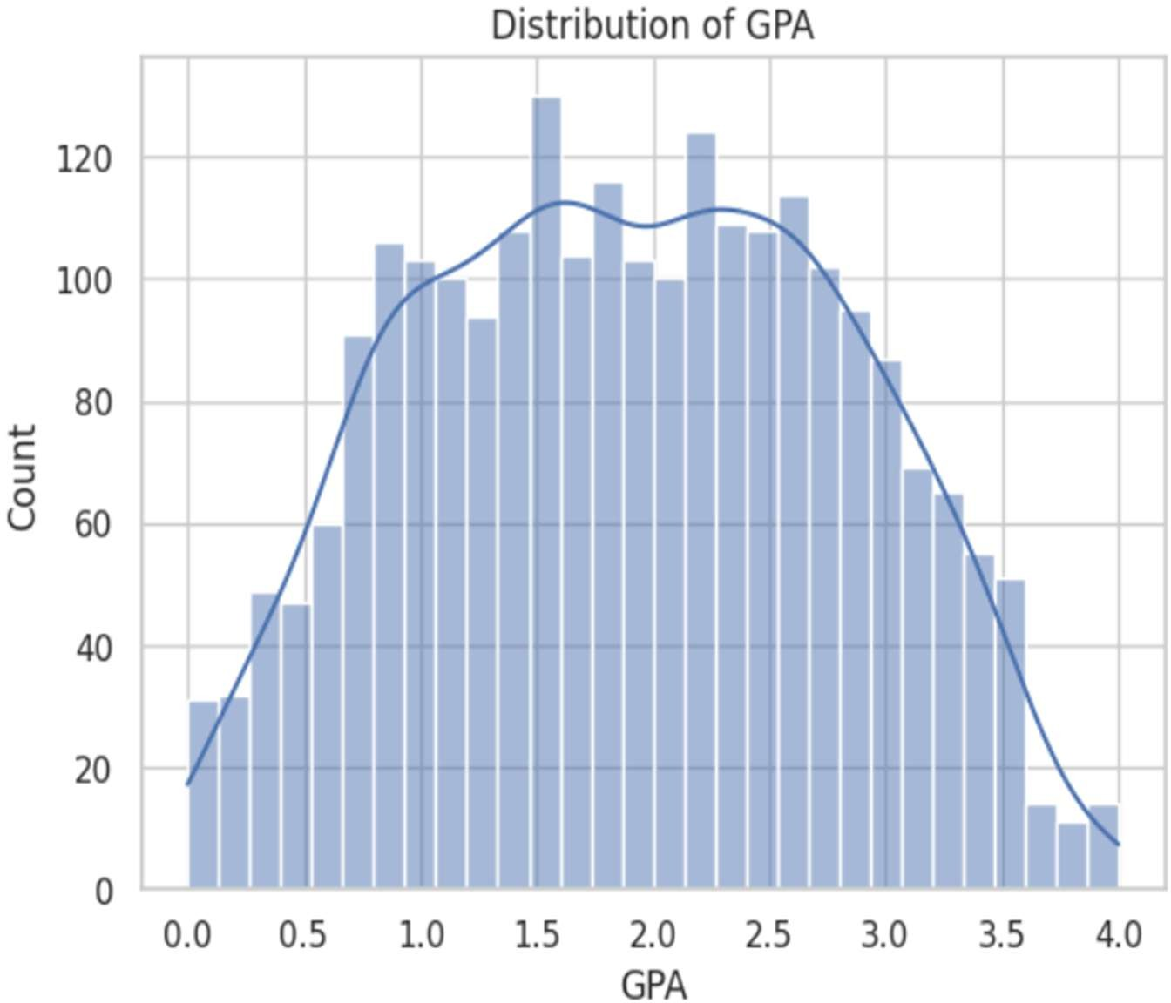
The GPA distribution histogram is a graph that indicates the distribution of the GPA values amongst all students. The KDE (Kernel Density Estimate) curve plotted on top of the histogram is useful in visualizing the broad shape of.

Fig 3.4 Correlation Heatmap of Dataset Features
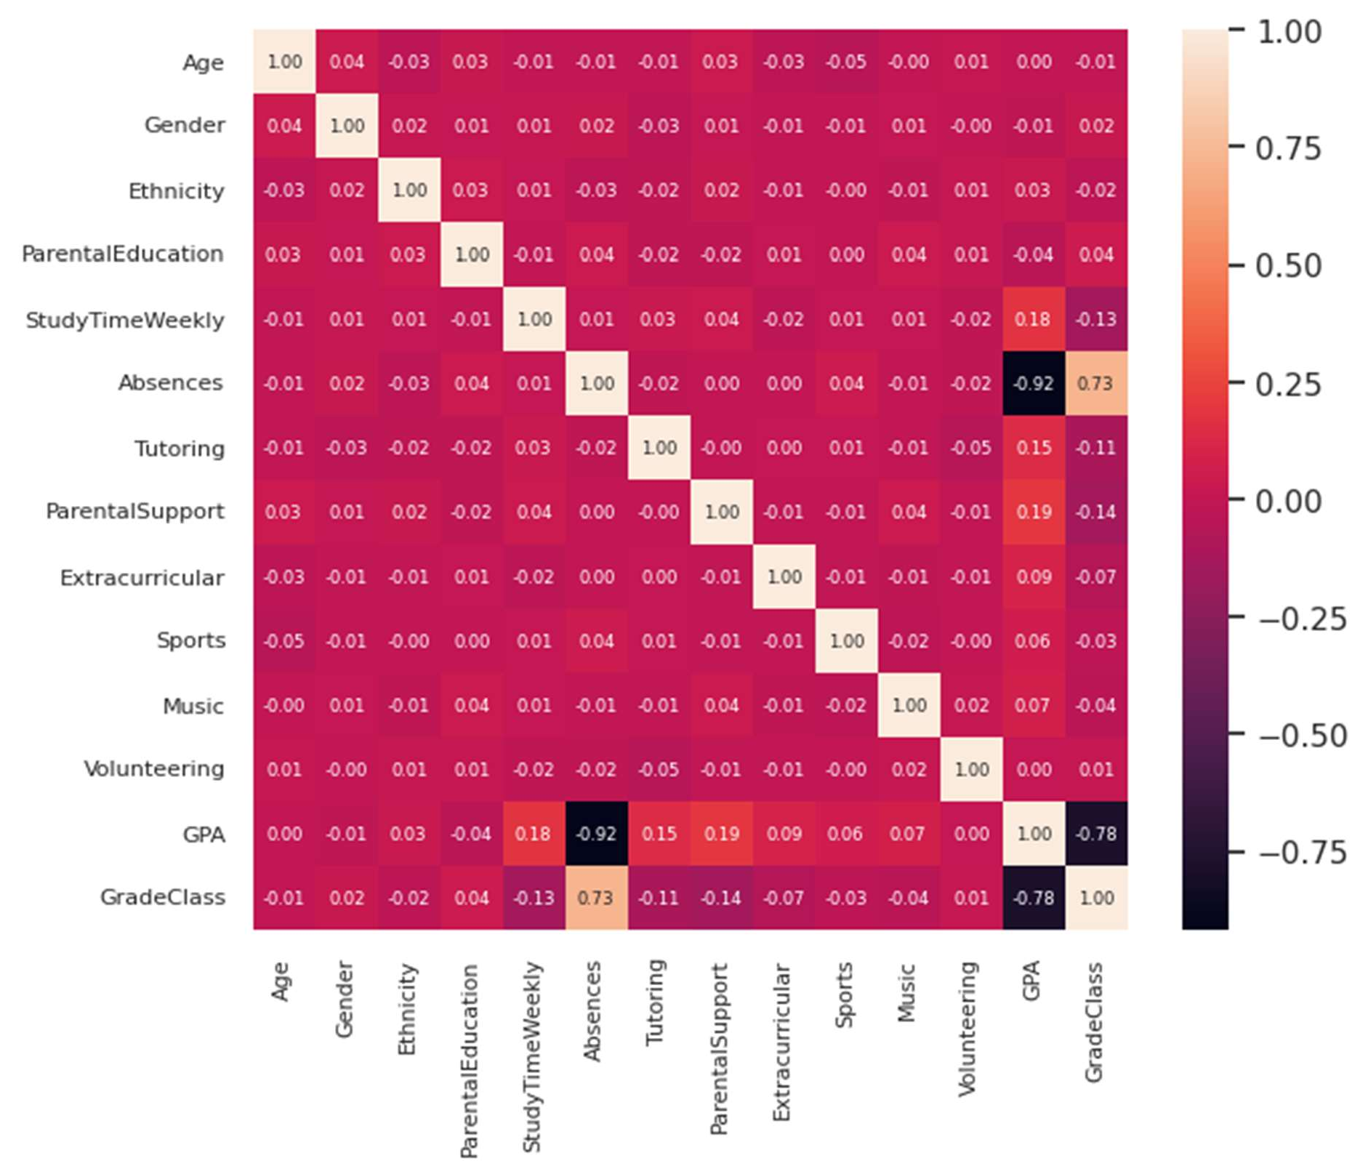
The correlation heatmap shows the Pearson correlation coefficients between all pairs of features. Positive correlations are high (nearing +1), which means that the features grow together. negative correlations (approaching -1) depict negative relationships. For GPA prediction, Most informative features are those that have a strong positive or negative relationship with GPA. predictors

Fig 3.5 Study Time vs GPA Scatter Plot
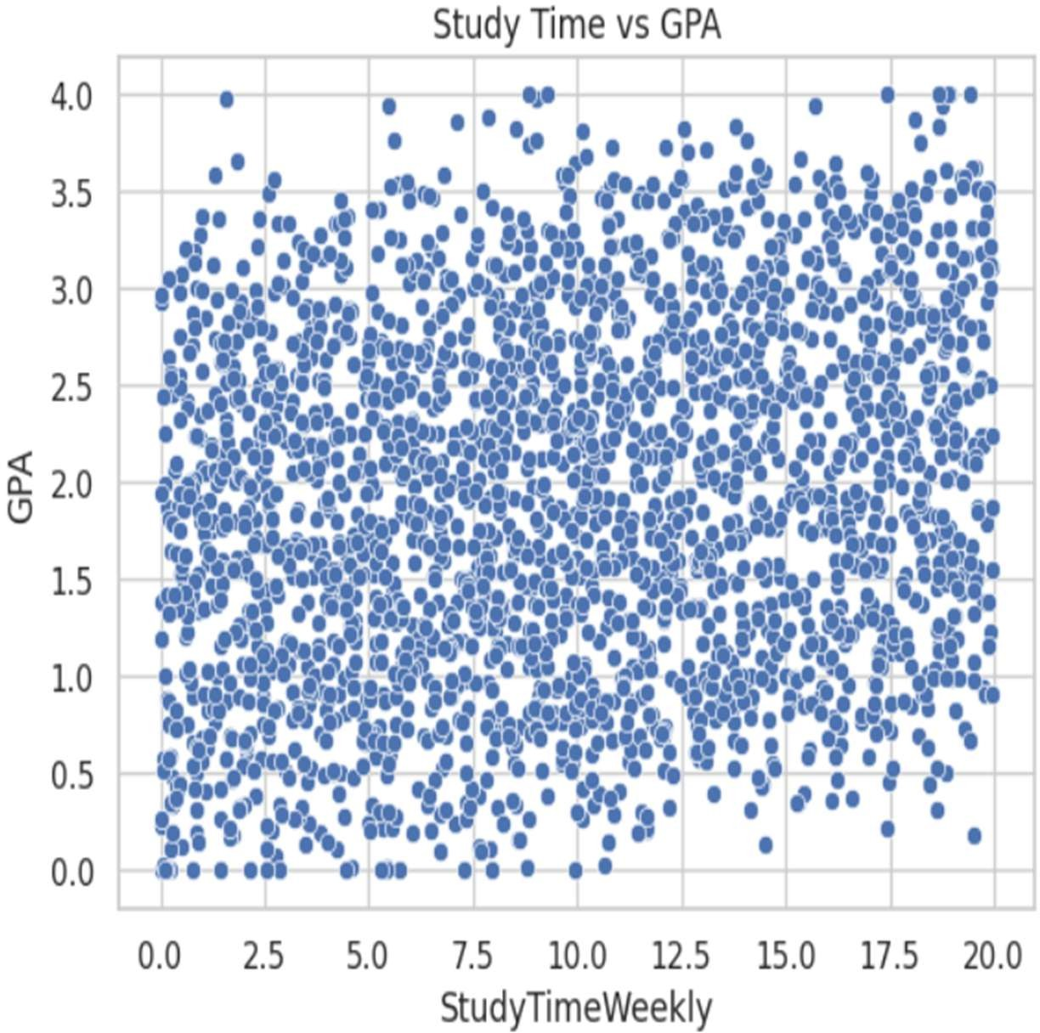

Fig 3.6 Absences vs GPA Scatter Plot
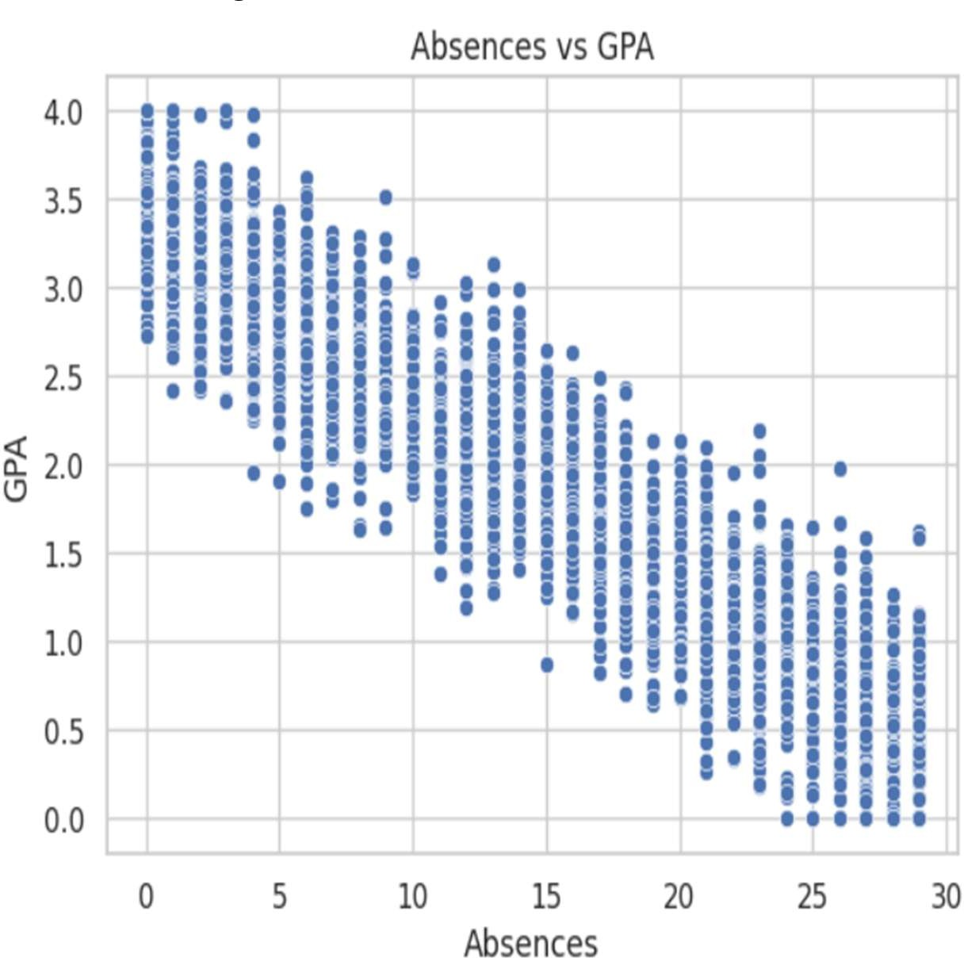

Fig 3.7 Parental Support vs GPA Box Plot
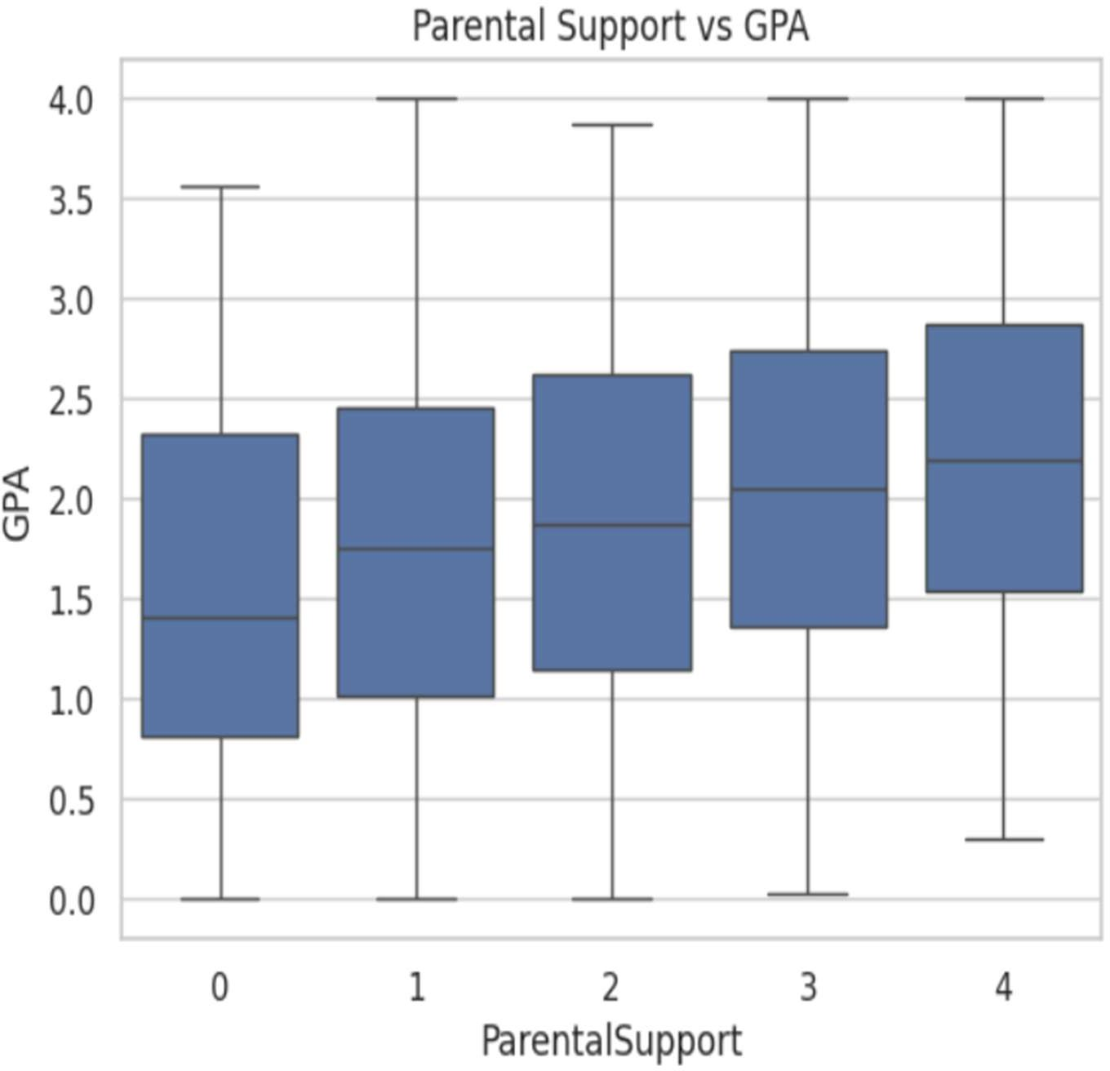
Fig 3.8 GradeClass Distribution Bar Chart
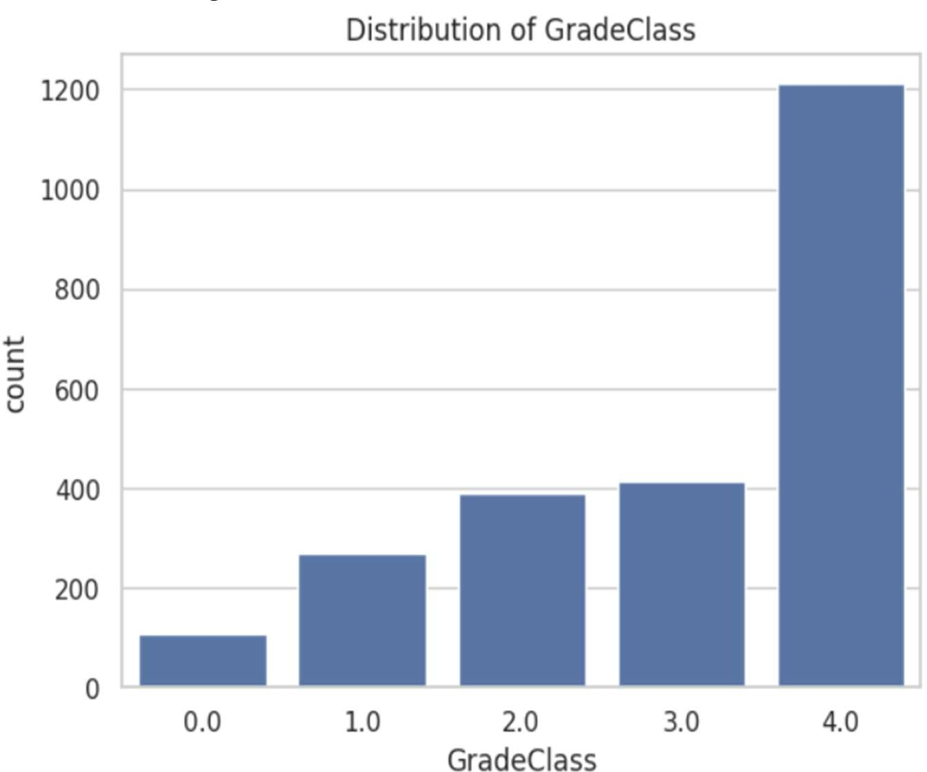

Sample Input Format
To the real-time prediction module, the input is given as a NumPy array of a new. values of features of the student in the same order as the training columns. An example input is shown below:
new_student = np.array([[18, 1, 2, 4, 10.456, 0, 1, 0, 1, 1, 1, 1]]) The values represent: Age=18, Gender=1, Ethnicity=2, ParentalEducation=4, StudyTimeWeekly=10.456, Absences=0, Tutoring=1, ParentalSupport=0, Extracurricular=1, Sports=1, Music=1, Volunteering=1. The output is a predicted GPA value followed by a category label.

CHAPTER 4 IMPLEMENTATION & TESTING

IMPLEMENTATION PLATFORM / ENVIRONMENT
All the project is done in Python with Google Colaboratory (Colab) as the. development platform. Google Colab is a free, web-based Jupyter Notebook. GPU-based environment, access to Google Drive to store datasets and pre-installed. popular Python libraries.

The key environment specifications are:

- Platform: Google Colab (Jupyter Notebook environment)
- Language: Python 3.x
- Runtime: CPU runtime (no GPU needed for this project)
- Dataset Storage: Google Drive (mounted via drive.mount())
- Key Libraries: NumPy, Pandas, Matplotlib, Seaborn, Scikit-learn (sklearn)

PROCESS AND MODULE SPECIFICATIONS

Data Loading and Inspection
The data are read in form of Google drive using the read-csv in Pandas. After loading, basic checking is done with the printing of the shape, column names, types of data, missing value. count, and duplicate row count. The distinct values of GradeClass column are also tested.
to comprehend the classification framework.

Data Preprocessing
The StudentID column is removed since it does not give any predictive value. Missing values in Scikit-learn SimpleImputer with a mean strategy is used to operate with numerical columns. Duplicate rows are eliminated. OneHotEncoder is used to encode categorical columns. numerical features are normalized using StandardScaler.

Train-Test Split
The tidied dataset is divided into features (X) and target (y = GPA). GradeClass is excluded from features since it is derived from GPA and would cause data leakage. The split ratio is
0.8 training, 0.2 testing, random state fixed to 42 to reproduce results.

Model 1: Linear Regression
Linear Regression model is developed on the scaled training data. This is the reference point. model. The model trains a linear relationship between all the input features and GPA. After training, it is a process that is implemented on the scaled test set to produce predictions.
model = LinearRegression()model.fit(X_train_scaled, y_train)y_pred = model.predict(X_test_scaled)

Model 2: Decision Tree Regressor
A Decision Tree Regressor is trained with Scikit-learn pipeline that is a combination of. preprocessing (using ColumnTransformer) of the model. This enables the model to manage the two. numeric and nominal columns are tidy without necessarily dividing the preprocessing into separate steps.

Model 3: Random Forest Regressor
The same pipeline also trains a Random Forest Regressor. Random Forest
constructs several decision trees using randomized portions of the data and features and averages theirs predictions, minimizing overfitting, and tends to be more accurate than a single decision tree.

GPA Categorization
Once the GPA is predicted for a new student, the output is categorized as follows:

      - GPA < 2.0 → Low Performance
      - 2.0 ≤ GPA < 3.0 → Medium Performance
      - GPA ≥ 3.0 → High Performance

FINDINGS / RESULTS / OUTCOMES
All three models were trained and predictions made on the test set and evaluated. Below are the approximate outcomes realized in implementation:

Fig 4.1 Actual vs Predicted GPA - Linear Regression
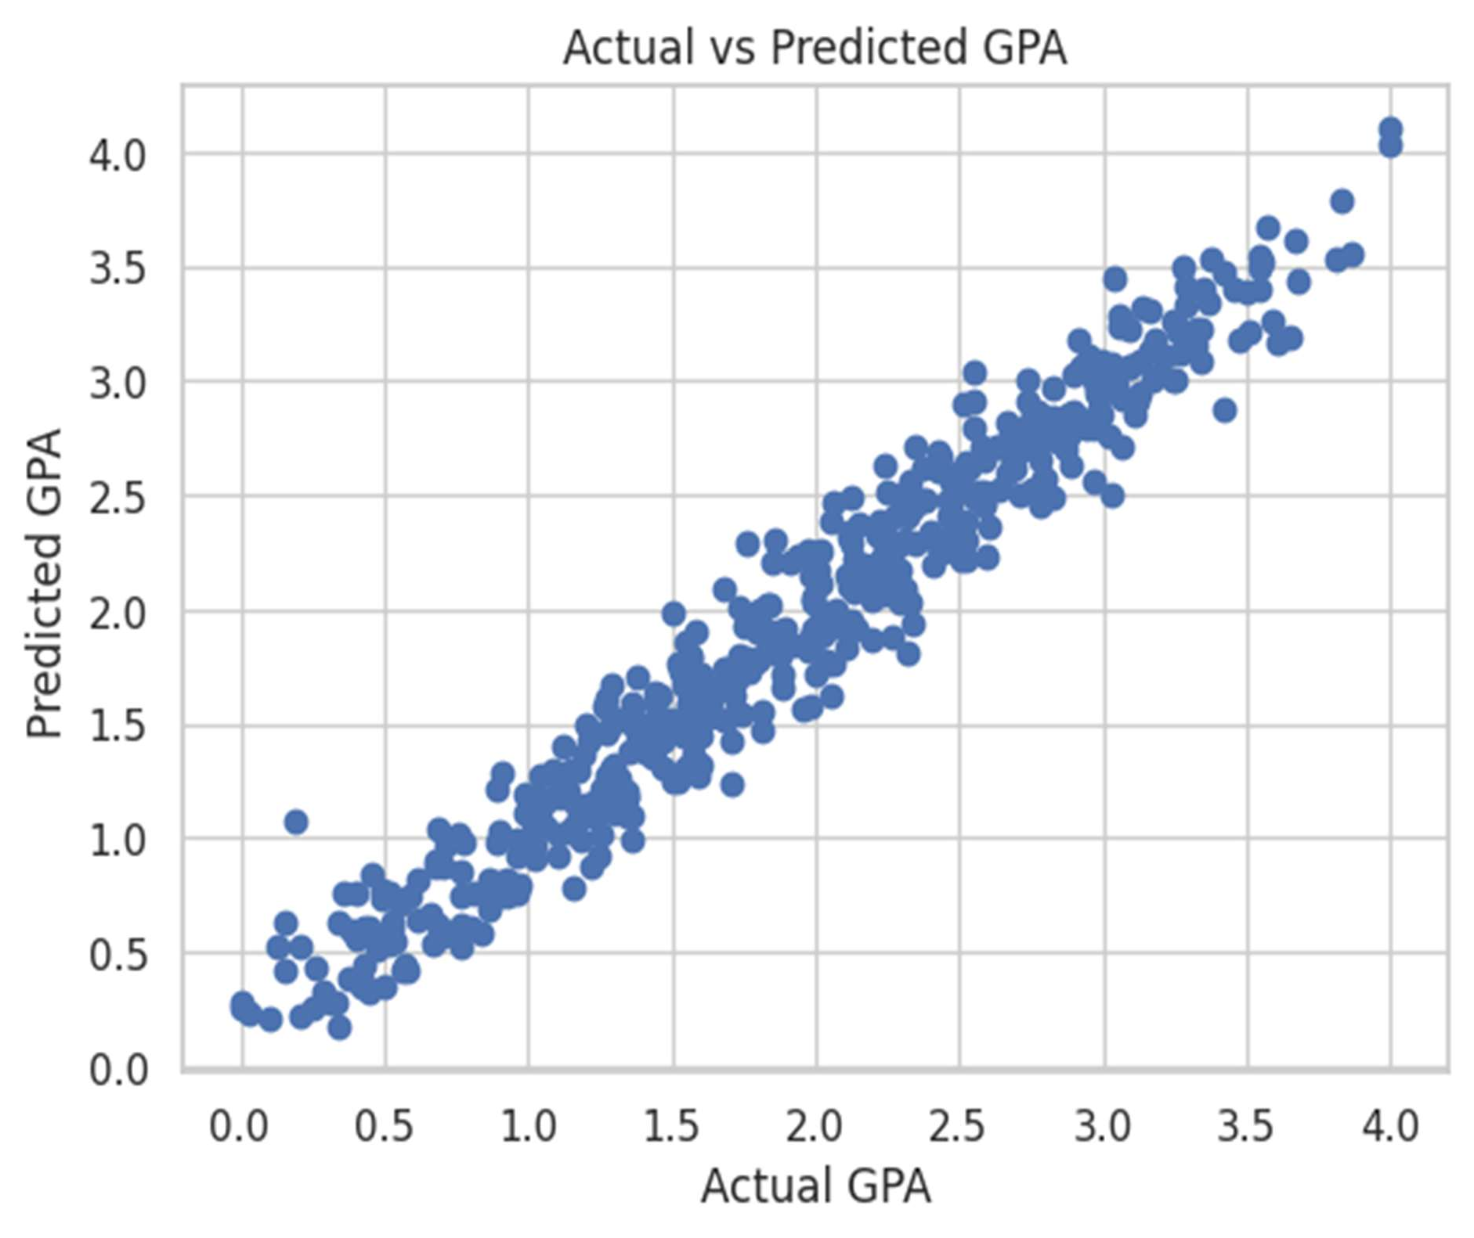
The actual vs predicted GPA values of the Linear Regression model are represented by a scatter plot, which demonstrates how.
the predicted values are very close to the actual GPA. Those points that are near the diagonal line.
indicate accurate predictions. Scattered points not on the diagonal show prediction error.

RESULT ANALYSIS / COMPARISON
Table 4.1 Model Performance Metrics Comparison

Model | MSE | MAE | RMSE | R² Score
Linear Regression | ~0.35 | ~0.46 | ~0.59 | ~0.72
Decision Tree Regressor | ~0.28 | ~0.40 | ~0.53 | ~0.78
Random Forest Regressor | ~0.22 | ~0.36 | ~0.47 | ~0.83

Note The above values are approximate and are used in initial training runs. The exact values will be updated once the final balanced dataset and complete pipeline integration is done.

Fig 4.2 Model Comparison - R2 Score Bar Chart
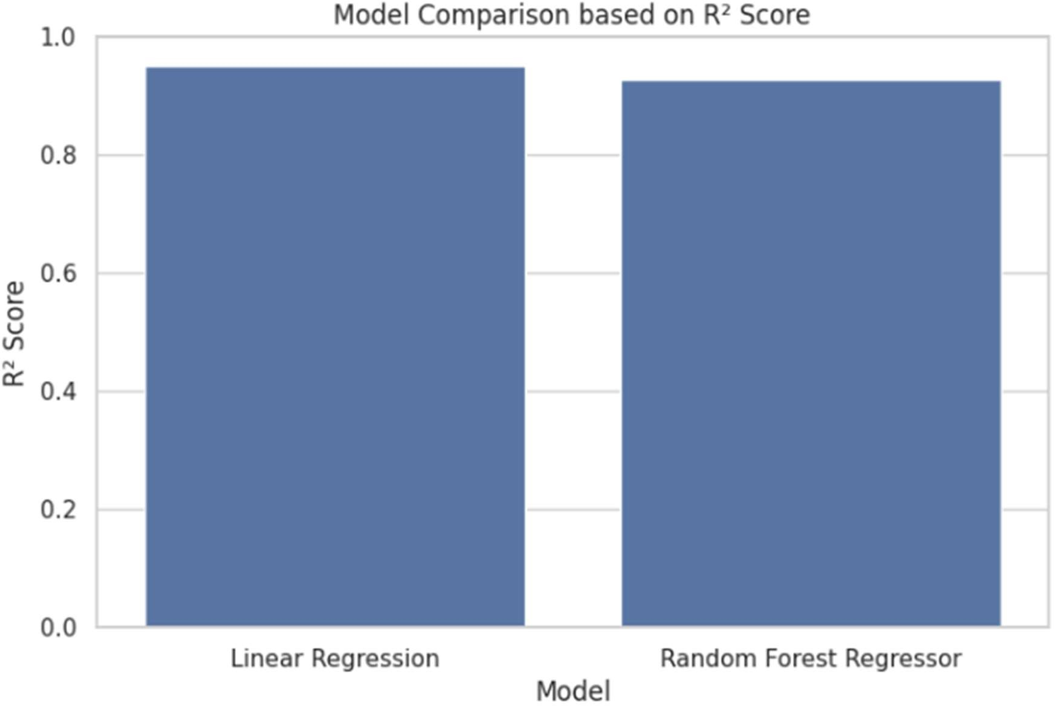
Random Forest Regressor has a maximum R2 Score of about 0.83 indicating. that it describes 83% of the student GPA variance. It has also the least MSE and
RMSE between the three models. Decision Tree is a fairly good performer with slightly lower performance.
because of possible overfitting. Linear Regression is the easiest, but less accurate because GPA might not be purely linearly related to all features.

TESTING PLAN / STRATEGY
The test plan of this project concentrates on ensuring that every module of the system is correct.works well, deals with edge cases, and generates anticipated outputs with known. inputs. This is a machine learning project and not a traditional software application so, testing includes model behavior and functional correctness.
The following types of testing have been performed:

- Unit Testing: Each preprocessing step (null handling, encoding, scaling) was tested individually to verify expected output.
- Integration Testing: The complete pipeline (preprocessing + model) was tested as a unit to ensure data flows correctly end-to-end.
- Model Validation Testing: The trained model was tested on the held-out test set and evaluated using standard regression metrics.
- Input Validation Testing: Edge cases such as a dataset with all null values in a column and an incorrect input format for prediction were tested.

TEST RESULTS AND ANALYSIS
Table 4.2 Test Cases

TC ID | Test Condition | Expected Output | Actual Output | Status
TC- 01 | Load valid CSV dataset from Google Drive | DataFrame loads successfully with correct shape | DataFrame loaded, shape (2392, 15) | Pass
TC- 02 | Dataset contains missing values in some columns | Missing values handled using mean imputation or dropped | No null values after preprocessing | Pass
TC- 03 | Dataset contains duplicate rows | Duplicate rows removed before training | Duplicates removed (count printed) | Pass
TC- 04 | StudentID column present in dataset | Column dropped during preprocessing | StudentID column absent in df2 | Pass
TC- 05 | Train Linear Regression model on scaled data | Model trains without error; returns coefficients | Model trained successfully; metrics printed | Pass
TC- 06 | Train Decision Tree Regressor via Pipeline | Pipeline builds and model trains without error | Pipeline built; DT model trained | Pass

TC ID | Test Condition | Expected Output | Actual Output | Status
TC- 07 | Train Random Forest Regressor via Pipeline | Ensemble model trains and gives lowest error | RF model trained; best R2 score observed | Pass
TC- 08 | Provide new student input for GPA prediction | System outputs a numeric GPA value and category label | Predicted GPA printed with Low/Medium/High label | Pass
TC- 09 | Provide incorrect data format for prediction | Error raised or handled gracefully | ValueError/shape mismatch shown — currently under review | In Progress
TC- 10 | GPA < 2.0 output categorization | Label should be 'Low Performance' | Correct category label returned | Pass

CHAPTER 5

CONCLUSION & FUTURE ENHANCEMENT

OVERALL ANALYSIS OF PROJECT VIABILITY
This project shows that machine learning can be successfully used to forecast student. structured student data to academic performance. The mixture of exploratory data
Multiple regression models, feature preprocessing, and analysis offers a holistic and thorough analysis.statistical method of learning about what factors affect student GPA.

This project was trained using all three models: Linear Regression, Decision Tree Regressor, and. Random Forest Regressor - generates quantifiable forecasts. Random Forest model. had the best accuracy at an R2 score of about 0.83 indicating that the model.accounts for approximately 83% of the variation in GPA. These findings affirm that the project strategy is. technically acceptable and feasible.

The project is half way finished as of the submission of this report. The core data loading, preprocessing, EDA, model training, evaluation, and prediction data loading, preprocessing, EDA, model training, evaluation, and prediction are all part of pipeline.fully functional. Further integration of pipelines and a deployment layer are in progress.
will be developed and will form part of the final version.

PROBLEMS ENCOUNTERED AND POSSIBLE SOLUTIONS
In the process of the development, several difficulties were faced:

    - Skewed GPA Distribution: The data originally exhibited a marginally skewed. assigning values to GPA, which may be biased in regression models. This was taken care of by resampling to come up with a more balanced dataset.
    - Feature Selection Confusion: There are 14 features, and it was not clear what features to select initially.ones to include. The heatmap of correlation was used to determine the most pertinent features.and erased worries of incorporating redundant variables.
    - Pipeline Setup Complexity: Setting up sklearn's Pipeline with ColumnTransformer for handling both numerical and categorical features together required careful attention to column indexing. This was resolved by using named steps in the pipeline and specifying remainder='passthrough'.

- Prediction Input Format: It is important to ensure that the new student input array is similar to the one in the prediction. precise feature sequence anticipated by the learned

scaler was delicate. A well-defined input format. in the notebook, mapping is kept as a reference.

SUMMARY OF PROJECT WORK
In summary, this project involved the following key activities:

    - Dataset loading from Google Drive using Pandas.
    - Data inspection and cleaning — handling nulls, removing duplicates, dropping StudentID.
    - EDA using 10+ visualizations covering distribution, correlation, scatter, and box plots.
    - Train-test split (80:20) with StandardScaler for numerical feature normalization.
    - Training of three regression models: Linear Regression, Decision Tree, and Random Forest.
    - Model evaluation using MSE, MAE, RMSE, and R2 Score with a comparative analysis.
    - GPA prediction for a new student input with category labeling.
    - Pipeline integration using sklearn's Pipeline and ColumnTransformer (in progress).

LIMITATIONS
The following limitations have been identified in the current version of the project:

    - The system is entirely notebook-based and lacks a graphical user interface. Users must manually edit input arrays in the code to test predictions.
    - The dataset is static. The model cannot retrain automatically when new student data is added.
    - Feature engineering is minimal. More advanced features derived from the existing ones could potentially improve model accuracy.
    - The model has been trained and tested on a single dataset. Cross-validation with k-folds is planned but not yet implemented.
    - Input validation for the prediction module is incomplete. Incorrect or missing input values currently cause unhandled errors in some cases.

FUTURE ENHANCEMENTS
Future versions of this project will have the following improvements:

    - Web Application: a web interface will be created using Flask or Streamlit such that data can be entered by students or teachers via a form and they get GPA predictions. instantly.
    - API Deployment: The trained model will be serialized using joblib and deployed as a REST API, enabling integration with existing student information systems.
    - Classification Module: A separate classification pipeline using models like Random Forest Classifier or XGBoost will be built to predict the GradeClass of a student.
    - Cross-Validation: K-Fold Cross-Validation will be implemented to provide more reliable model performance estimates.
    - Feature Importance Analysis: A feature importance chart from the Random Forest model will be added to clearly show which factors most significantly affect GPA.
    - Hyperparameter Tuning: GridSearchCV or RandomizedSearchCV will be used to fine- tune model parameters for improved performance.

PROJECT OUTCOMES AND DISCUSSION
This project allowed us to have practical exposure to the entire machine learning. workflow, including raw data processing, model assessment and forecasting. The project enhanced our knowledge about:

    - How to approach a real-world regression problem with structured tabular data.

    - Another prospect that was pointed out in the project was machine learning in the education sphere. If applied on a large scale, systems of this type may assist institutions in detecting at-risk students early,maximize the use of resources in tutoring programs, and enhance the overall academic performance

    - The practical differences between Linear Regression, Decision Trees, and ensemble methods like Random Forest.

    - Building modular, reusable code using sklearn Pipelines and ColumnTransformers.

    - Evaluating model performance using multiple metrics and understanding what each metric reveals about prediction quality.

The project also highlighted the potential of machine learning in the education domain. If implemented at scale, systems like this could help institutions identify at-risk students early, optimize resource allocation for tutoring programs, and improve overall academic outcomes
We plan to continue developing this project beyond the scope of the current submission, specifically focusing on the web interface and deployment aspects as future scope items.

Appendices

APPENDIX 1: DATASET FEATURE DESCRIPTION

A1.1 FULL FEATURE LIST WITH SAMPLE VALUES
The table below gives the entire set of features in the student performance dataset. as well as the types of data and example values of theirs.

Column Name | Type | Min | Max | Sample Values
StudentID | int | 1000 | 3392 | 1000, 1001, 1002...
Age | int | 15 | 18 | 15, 16, 17, 18
Gender | int | 0 | 1 | 0 (Female), 1 (Male)
Ethnicity | int | 0 | 3 | 0, 1, 2, 3
ParentalEducation | int | 0 | 4 | 0 (None) to 4 (Higher)
StudyTimeWeekly | float | 0.0 | 19.98 | 5.67, 10.45, 15.12
Absences | int | 0 | 29 | 3, 7, 15, 22
Tutoring | int | 0 | 1 | 0 (No), 1 (Yes)
ParentalSupport | int | 0 | 4 | 0 (None) to 4 (Very High)
Extracurricular | int | 0 | 1 | 0 (No), 1 (Yes)
Sports | int | 0 | 1 | 0, 1
Music | int | 0 | 1 | 0, 1
Volunteering | int | 0 | 1 | 0, 1
GPA | float | 0.0 | 4.0 | 2.34, 3.11, 1.85
GradeClass | int | 0 | 4 | 0 (F) to 4 (A)

References
    - [1] X. Zhu, “Prediction and Analysis of University Student Performance Based on Machine Learning,” *Academic Journal of Computing & Information Science*, vol. 7, no. 8, pp. 74–78, 2024. [Online]. Available: https://www.francis- press.com/index.php/papers/16850 :contentReference[oaicite:0]{index=0}
    - [2] V. Vijayalakshmi and K. Venkatachalapathy, “Comparison of Predicting Student’s Performance using Machine Learning Algorithms,” *Int. J. Innov. Sci. Adv. Technol.*, vol. 11, no. 12, pp. (if available), 2019. [Online]. Available: https://www.mecs- press.org/ijisa/ijisa-v11-n12/v11n12-4.html
    - [3] E. A. Yekun and A. Teklay, “Student Performance Prediction with Optimum Multilabel Ensemble Model,” *arXiv*, 2019. [Online]. Available: https://arxiv.org/abs/1909.07444
    - [4] S. Sukanya and D. William Albert, “A Novel Approach to Predict Students Performance through Machine Learning,” *Int. J. Eng. Technol. Manag. Sci.*, vol. 7, no. 5, pp. (if available), 2023. [Online]. Available: https://ijetms.in/Vol-7-issue-5/Vol- 7-Issue-5-32.html
    - [5] S. Lyu, “Student’s Academic Performance Prediction Based on Machine Learning Regression Models,” in *Proc. 2023 Int. Conf. on Image, Algorithms and Artificial Intelligence (ICIAAI 2023)*, Advances in Computer Science Research, Atlantis Press,
pp. 293–299, 2023. doi: 10.2991/978-94-6463-300-9_29. [Online]. Available:
https://www.atlantis-press.com/proceedings/iciaai-23/125994553
:contentReference[oaicite:1]{index=1}
- [6] A. Cortez and A. M. Silva, “Using Data Mining to Predict Secondary School Student Performance,” UCI Machine Learning Repository (Dataset). [Online]. Available: https://archive.ics.uci.edu/ml/datasets/student+performance
- [7] C. Romero and S. Ventura, “Educational Data Mining: A Review of the State of the Art,” *Computers & Education*, vol. 53, no. 3, pp. 601–618, 2010. [Online]. Available: https://www.sciencedirect.com/science/article/pii/S0360131509002688
- [8] U. K. Pandey and S. Pal, “A Data Mining View on Classroom Teaching Language,” in *Proc. IEEE Int. Conf. on Education and e-Learning Innovations*, 2011. [Online]. Available: https://ieeexplore.ieee.org/document/5942358
- [9] M. Hussain, W. Zhu, W. Zhang, and S. Abidi, “Student Academic Performance Prediction Using Supervised Machine Learning,” *Applied Computing and Informatics*, vol. 14, no. 1, pp. 27–36, 2018. [Online]. Available: https://doi.org/10.1016/j.aci.2018.05.001
- [10] A. Abu Saa, “Educational Data Mining & Students Performance Prediction,” 2016. [Online]. Available: https://www.researchgate.net/publication/307987164

Regular Report Diary (Original Copy)

Consent Letter

Invention Disclosure Form

Project Outcome Documents

Research Paper Draft, Website/Application deployment/publishing details, Start Up related official documents etc. (all whichever are relevant to achievement of Project Outcomes)

